**IMDb Dataset SQL Analysis Report**

**Introduction**

This report presents an in-depth analysis of the IMDb dataset using advanced SQL queries. The dataset comprises multiple tables containing information about movies, genres, directors, actors, ratings, and other related details. The primary objective of this project is to reinforce key SQL concepts such as joins, aggregation, filtering, and grouping while extracting meaningful insights from the data.

**Dataset Overview**

The dataset consists of the following tables:

* **Movie**: Contains basic movie information (title, release year, duration, country, income, language, production company).
* **Genre**: Lists the genres associated with each movie.
* **Director Mapping**: Maps movies to their respective directors.
* **Role Mapping**: Links actors, directors, and producers to movies.
* **Names**: Stores details about individuals (actors, directors, etc.), including birthdate, height, and known movies.
* **Ratings**: Includes rating details such as average rating, total votes, and median rating.

**SQL Queries and Analysis**

This section details the queries used to analysis the dataset, along with explanations and insights derived from the results.

**1. Total Record Counts per Table**

**Query:** Retrieves the total number of records in each table.

**Findings:** Provides an overview of dataset size and completeness. 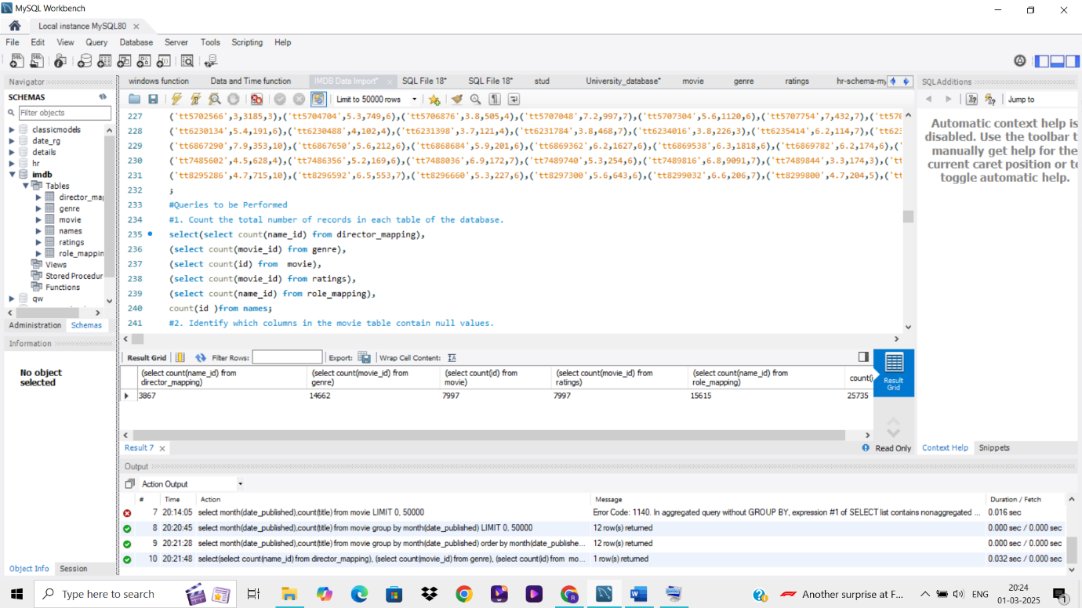

**2. Identifying Null Values in the Movie Table**

**Query:** Determines columns in the Movie table containing null values.

**Findings:** Helps assess data completeness and potential issues with missing values. 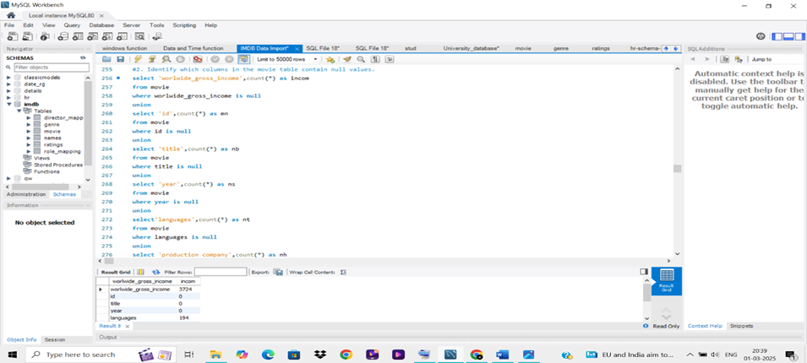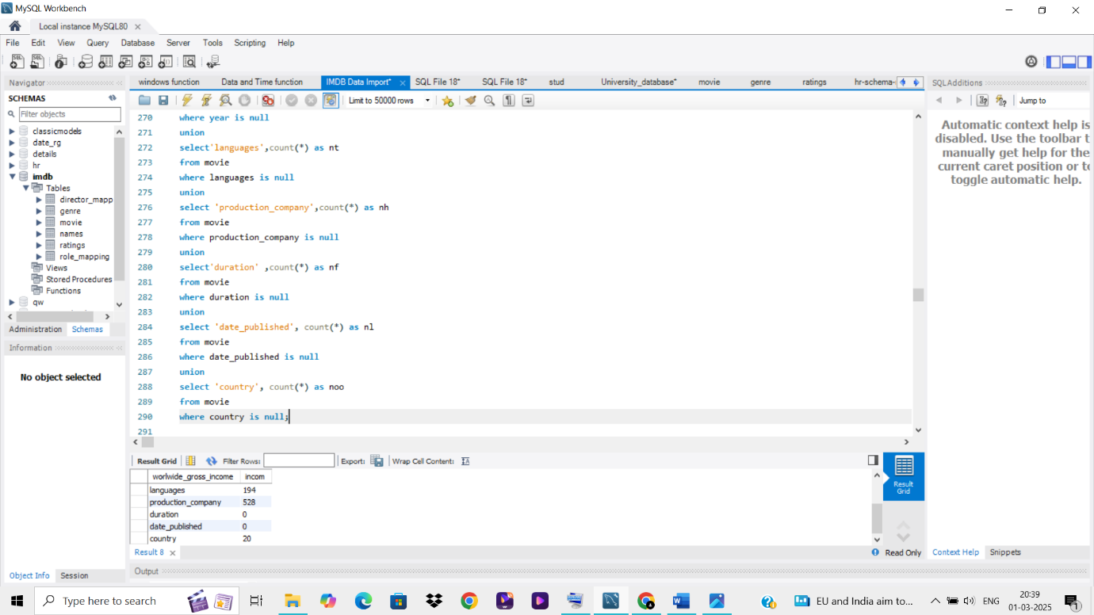

**3.Yearly and Monthly Movie Releases**

**Query:** Counts movies released each year and analysis monthly trends.

**Findings:** Identifies trends in movie production over time. 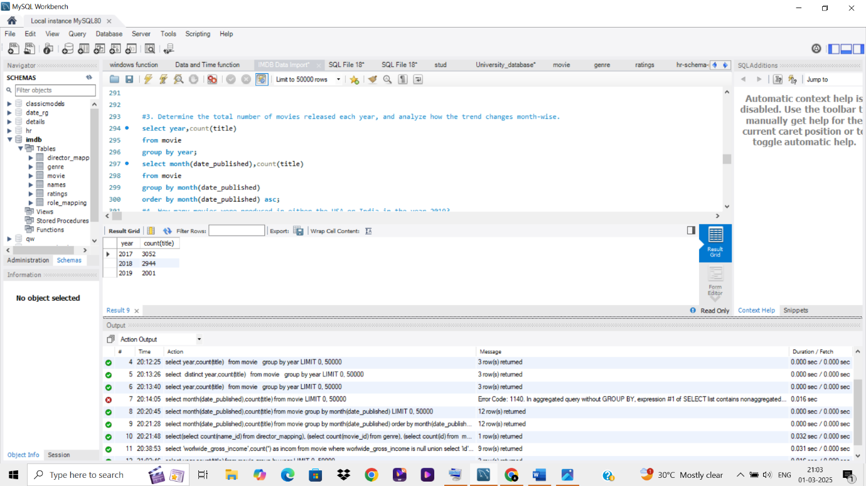

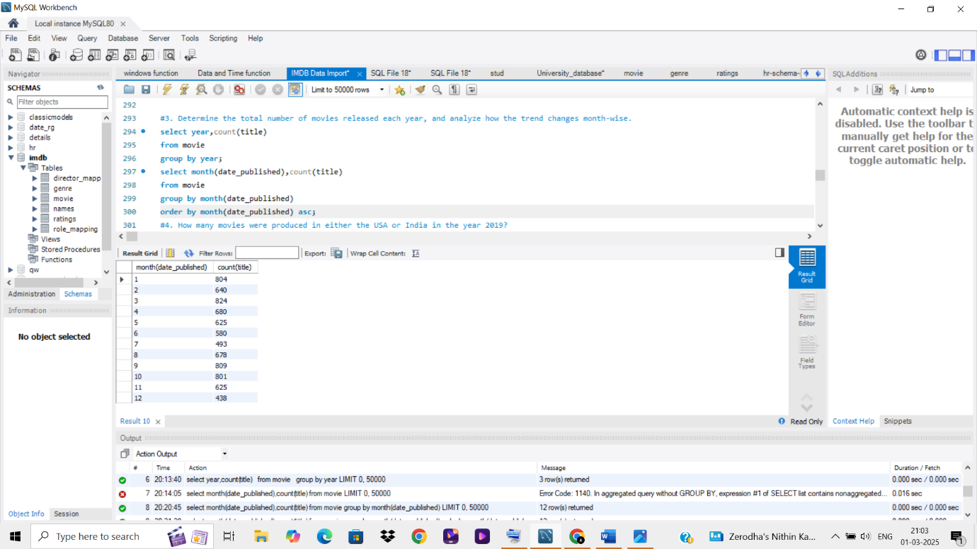

**4. Movies Produced in the USA or India (2019)**

**Query:** Counts movies from the USA or India released in 2019.

**Findings:** Provides insights into major movie-producing countries. 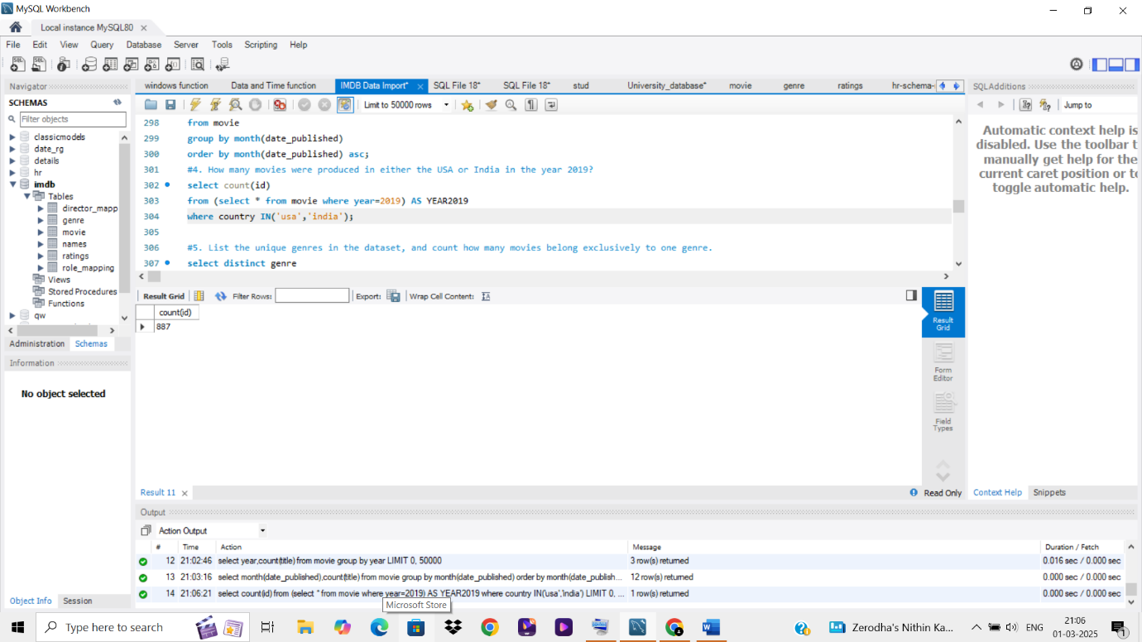

**5. Unique Genres and Exclusive Genre Movies**

**Query:** Lists unique genres and counts movies belonging exclusively to one genre.

**Findings:** Identifies diversity and specialization in movie genres. 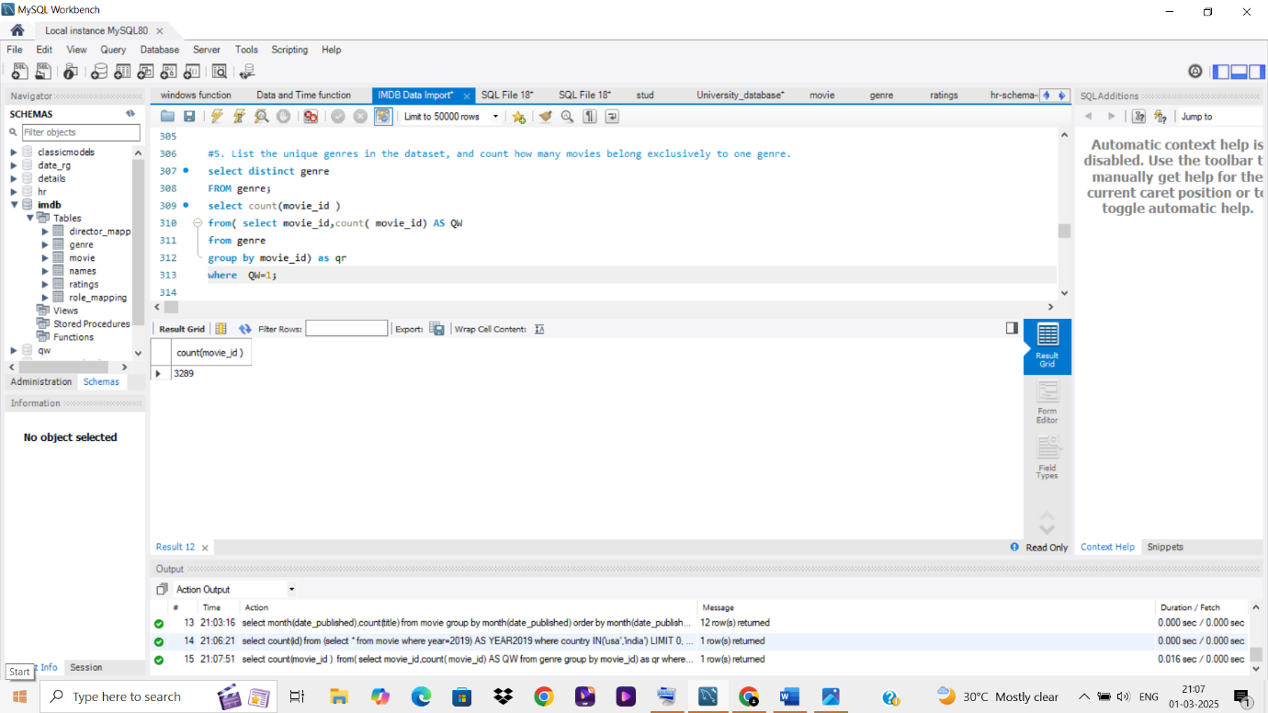

**6. Most Common Genre**

**Query:** Determines which genre has the highest number of movies.

**Findings:** Highlights dominant genres in the dataset. 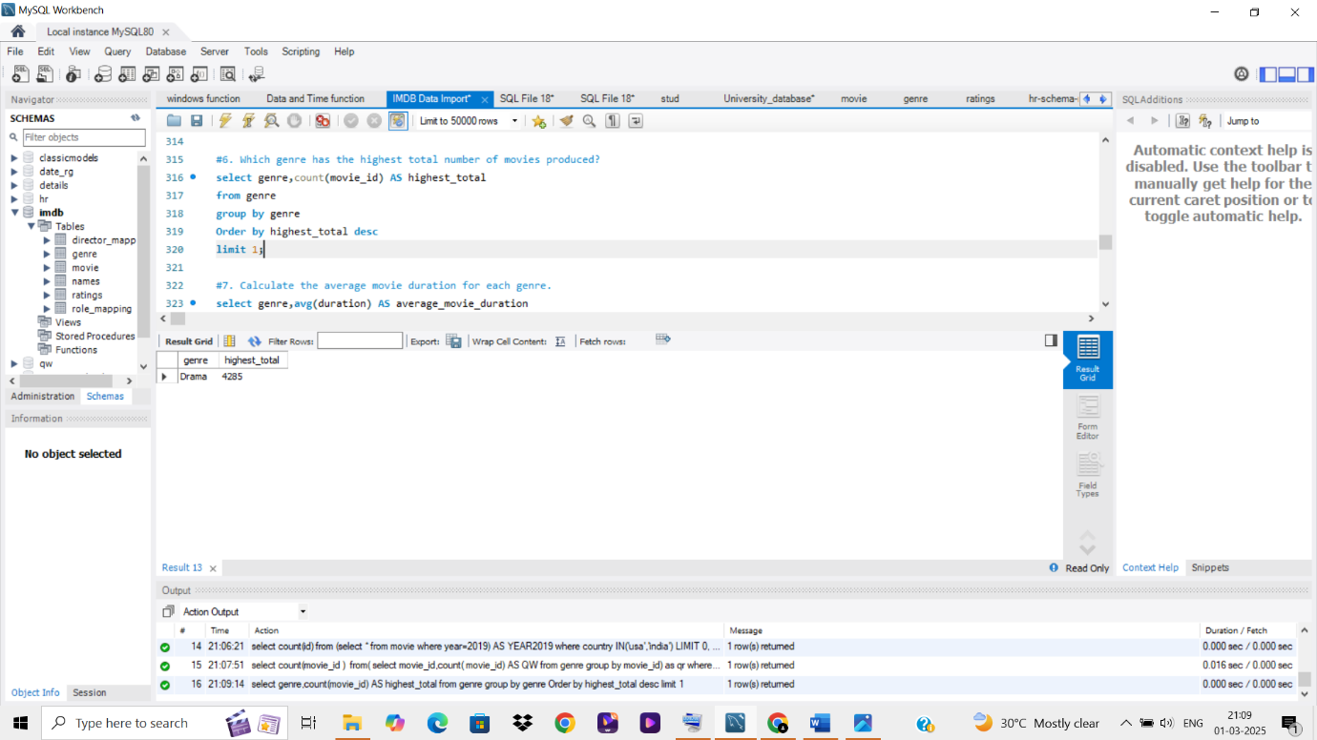

**7. Average Movie Duration per Genre**

**Query:** Calculates the average runtime of movies for each genre.

**Findings:** Shows variations in movie length across genres. 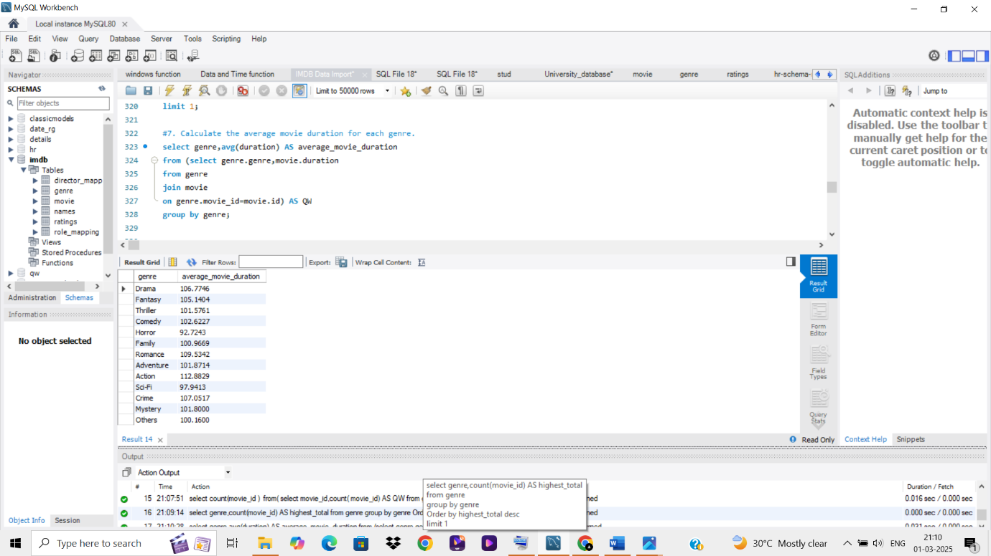

**8. Actors with Multiple Low-Rated Movies**

**Query:** Identifies actors who have appeared in more than three movies with an average rating below 5

**Findings:** Highlights actors frequently involved in poorly rated films. 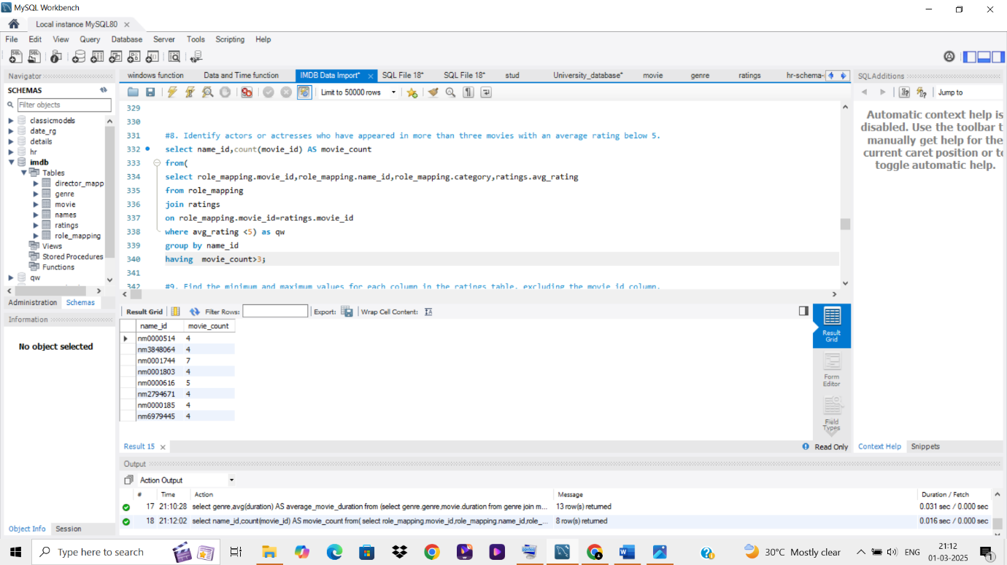

**9.Ratings Table Summary**

**Query:** Finds minimum and maximum values for each column in the Ratings table (excluding movie id).

**Findings:** Provides an overview of rating distribution. 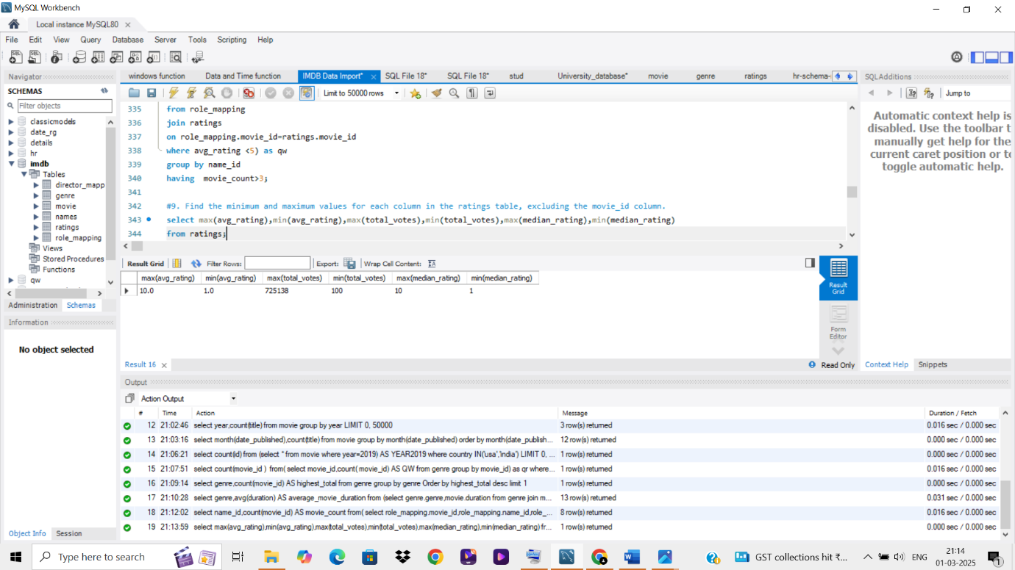

**10.Top 10 Movies by Average Rating**

**Query:** Identifies the highest-rated movies.

**Findings:** Lists top-performing movies in terms of viewer ratings. 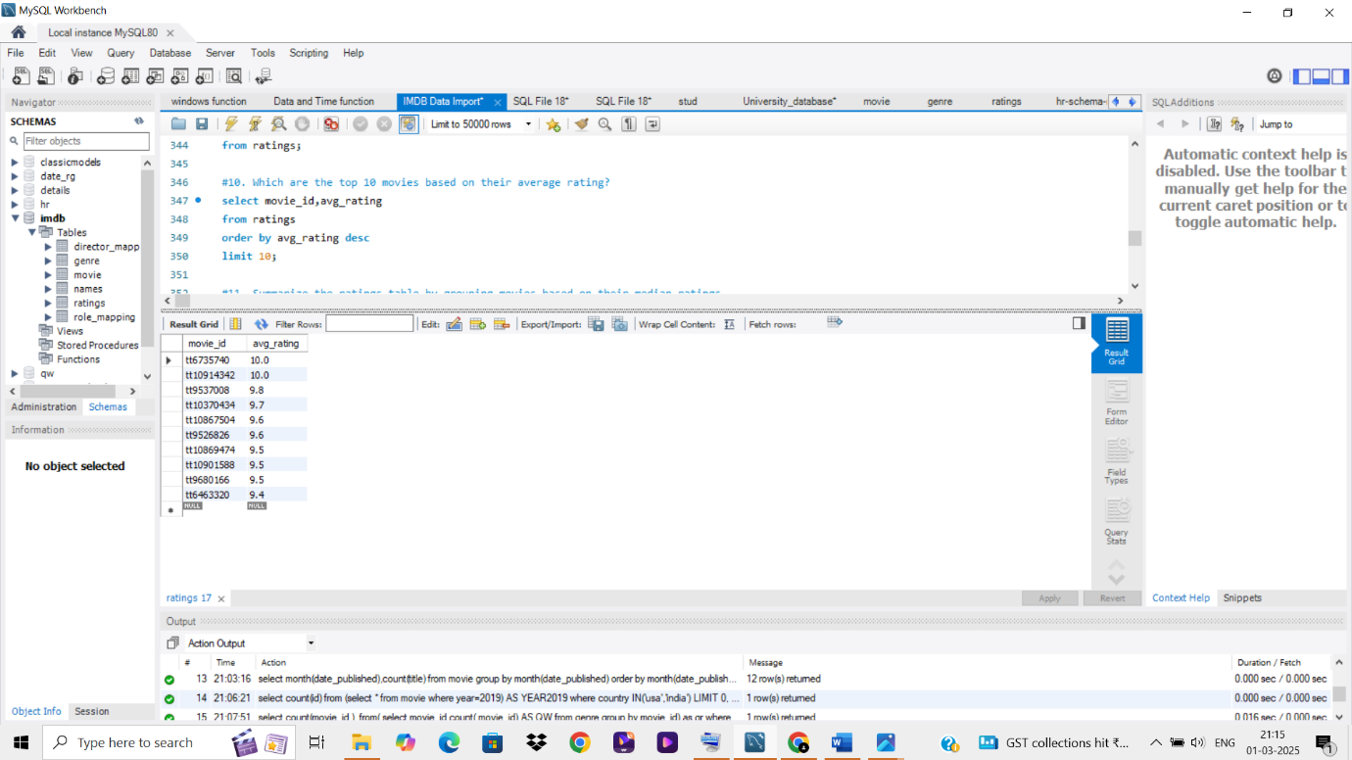

**11. Median Rating-Based Movie Grouping**

**Query:** Groups movies based on their median ratings.

**Findings:** Categorizes movies based on audience reception. 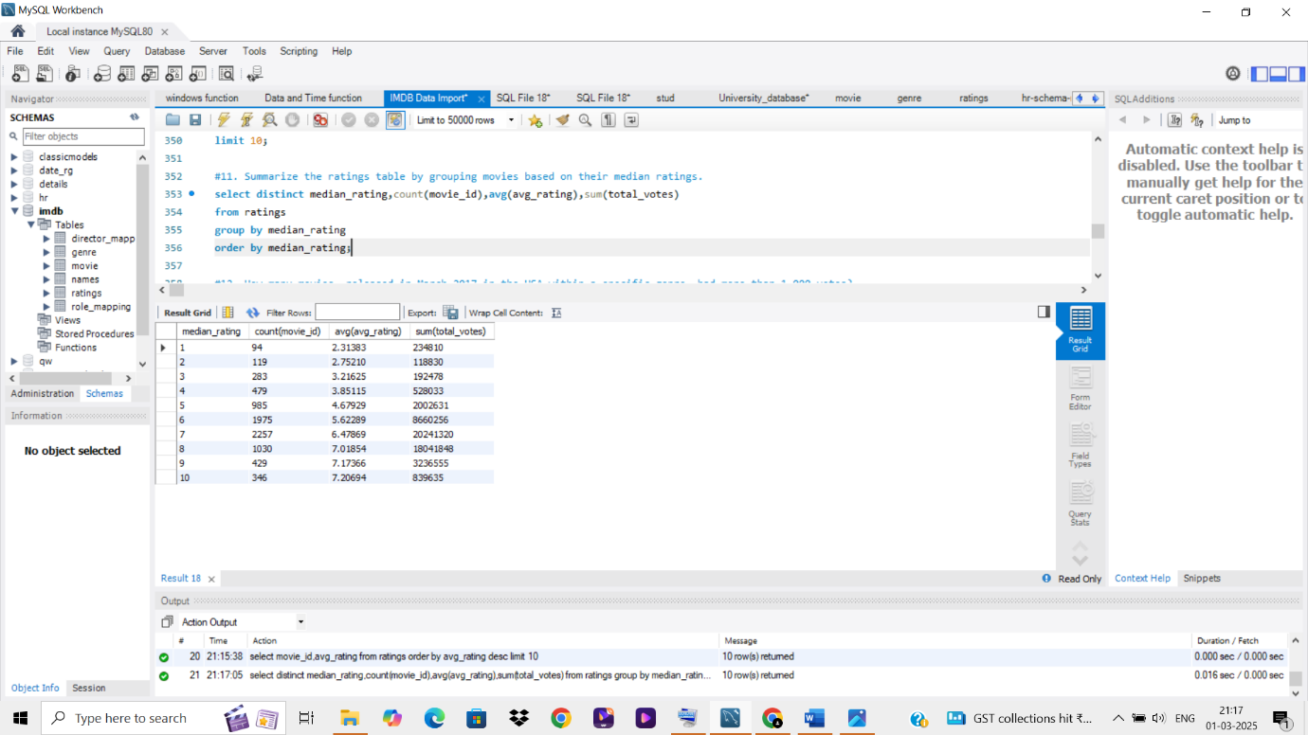

**12. High-Voted Movies in March 2017 (USA, Specific Genre)**

**Query:** Identifies movies released in March 2017 in the USA with more than 1,000 votes. **Findings:** Provides insights into popular releases from that period. 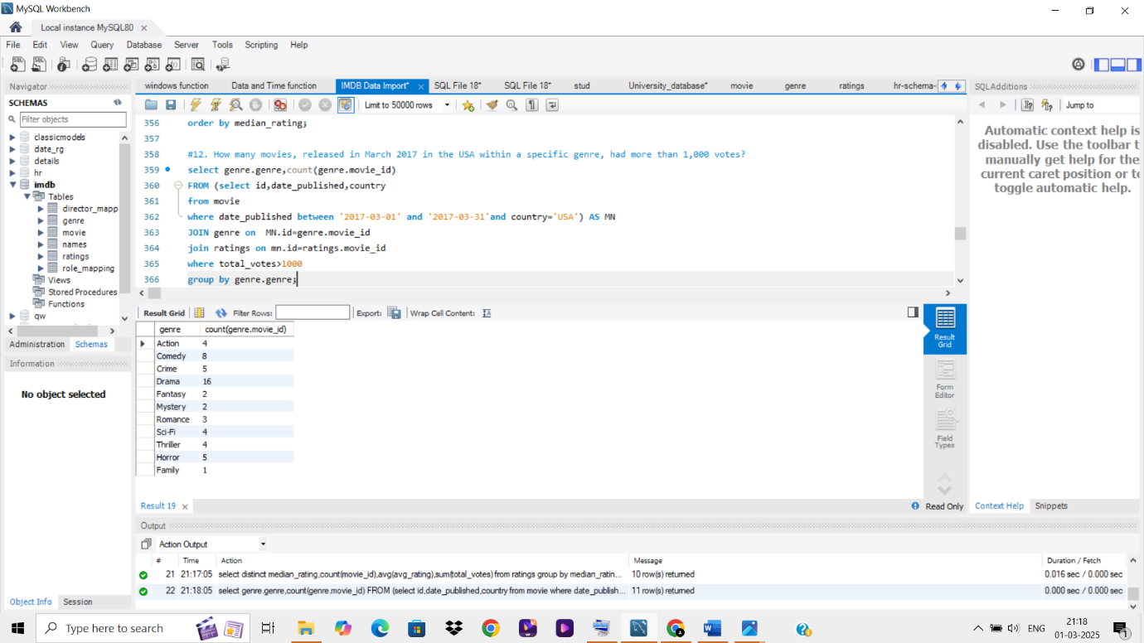

**13. Highly Rated Movies Starting with "The"**

**Query:** Finds movies in each genre that start with "The" and have an average rating greater than 8.

**Findings:** Identifies standout movies with similar naming conventions. 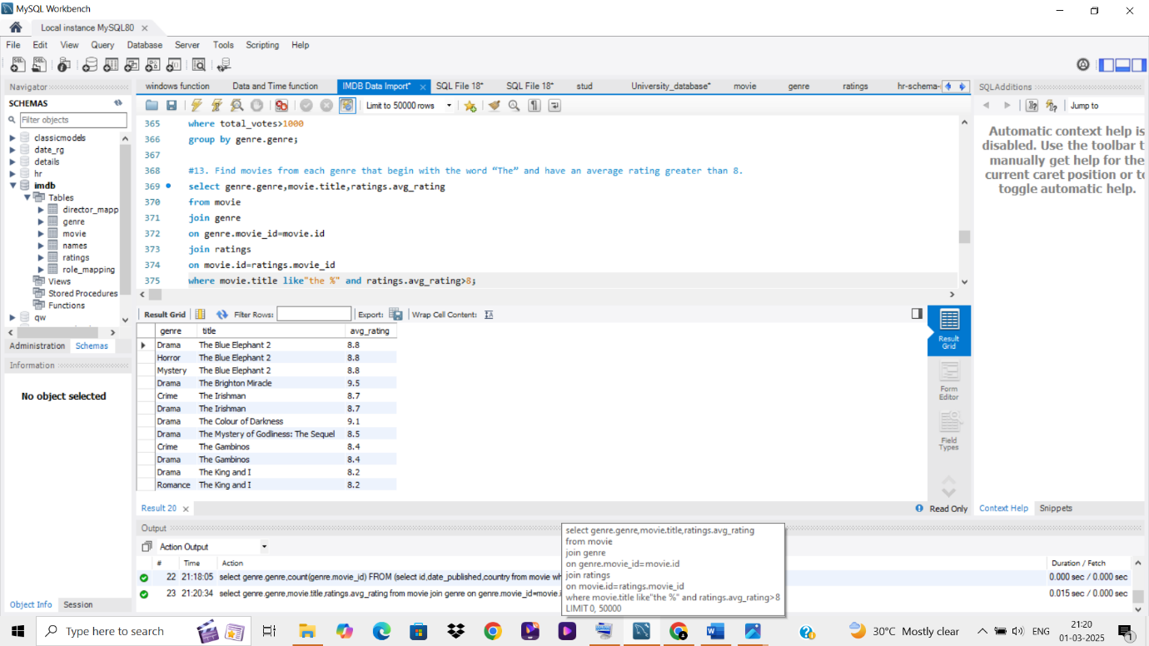

**14.Median Rating 8 (2018-2019)**

**Query:** Counts movies released between April 1, 2018, and April 1, 2019, with a median rating of 8.

**Findings:** Measures the volume of highly rated releases within that timeframe. 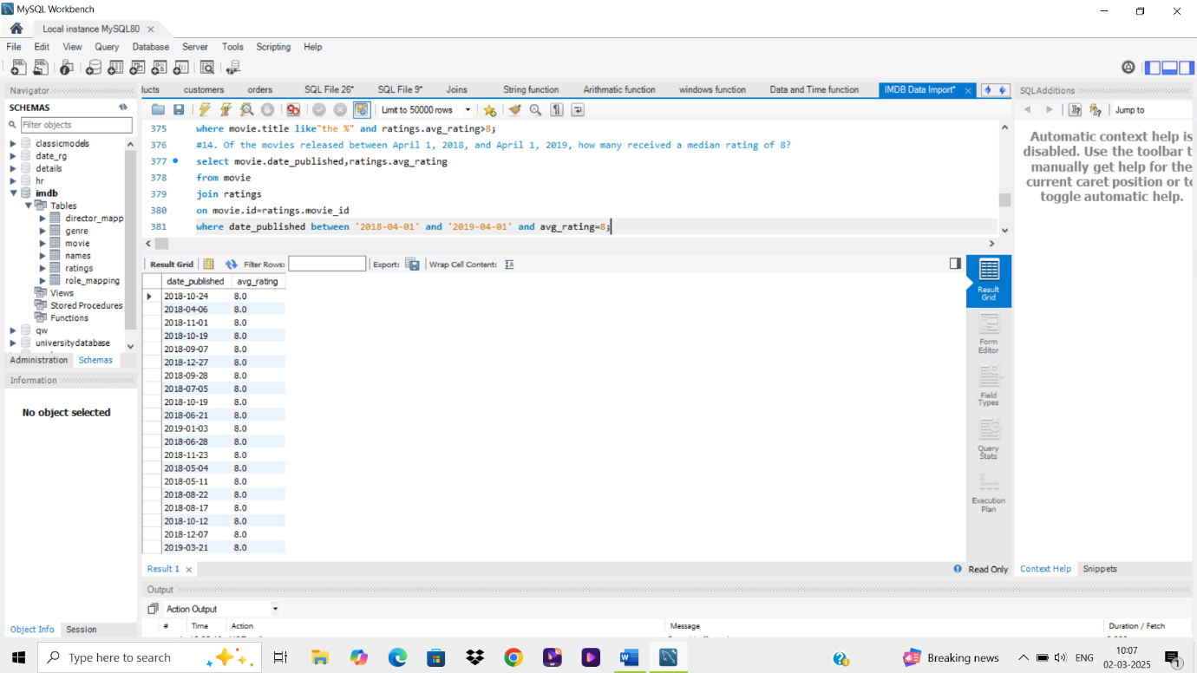

**15.German vs. Italian Movies – Average Votes**

**Query:** Compares the average number of votes for German and Italian movies.

**Findings:** Determines whether one country’s movies receive more engagement. 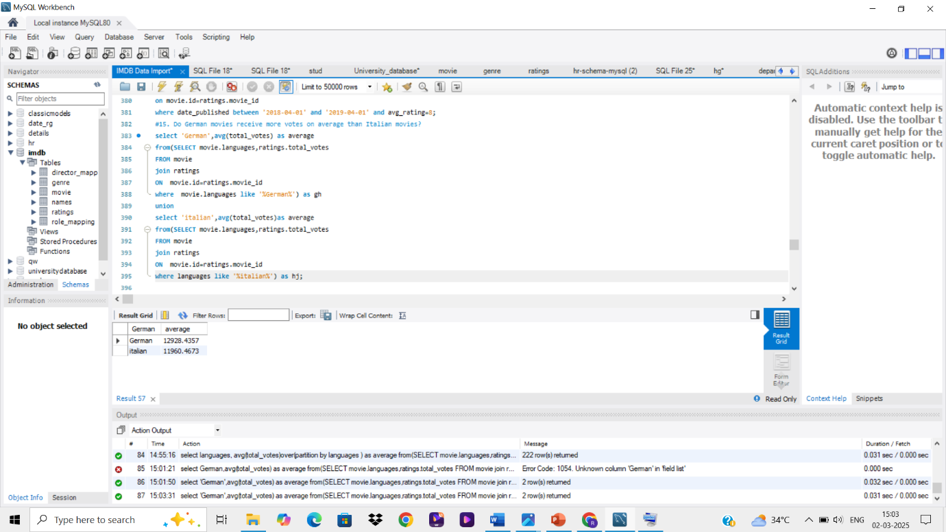

**16. Null Values in the Names Table**

**Query:** Identifies columns in the Names table with null values.

**Findings:** Helps assess data quality for individual records. 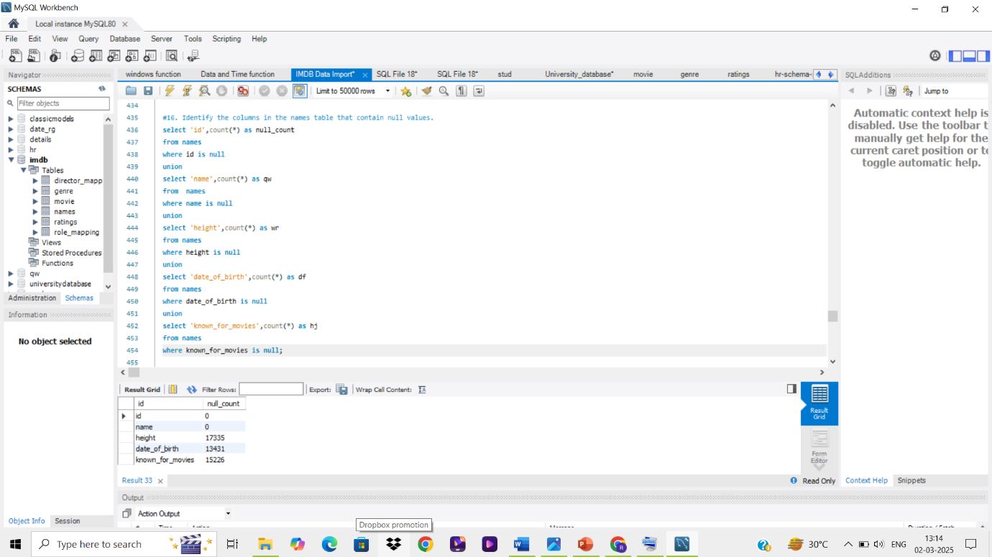

**17. Top Actors with Highly Rated Movies**

**Query:** Identifies the top two actors whose movies have a median rating of 8 or higher. **Findings:** Highlights actors frequently associated with quality films. 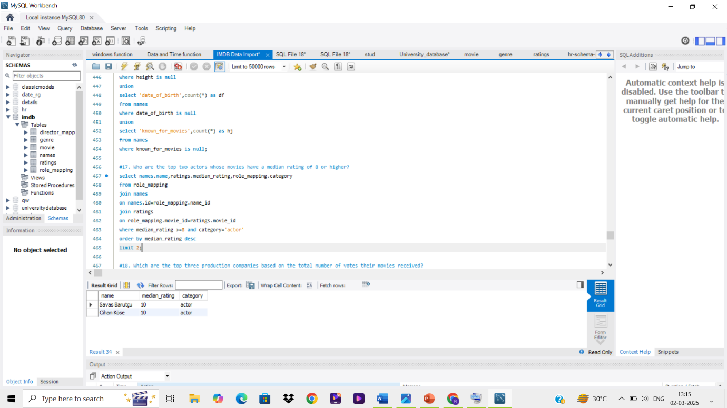

**18.Top 3 Production Companies by Total Votes**

**Query:** Determines the most influential production companies based on total votes received. **Findings:** Identifies major industry players. 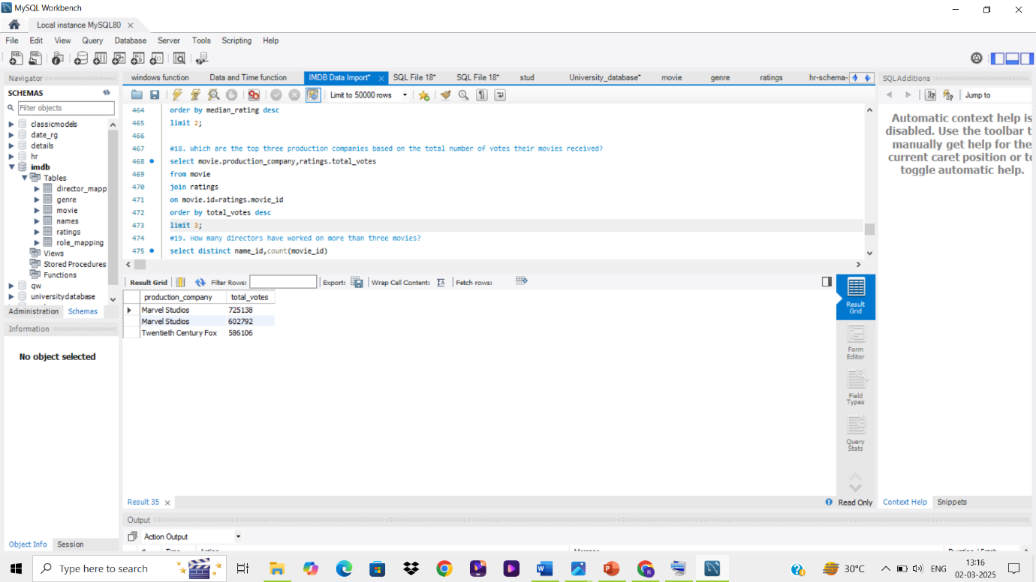

**19. Directors with More Than Three Movies**

**Query:** Finds directors who have worked on more than three movies.

**Findings:** Recognizes prolific filmmakers. 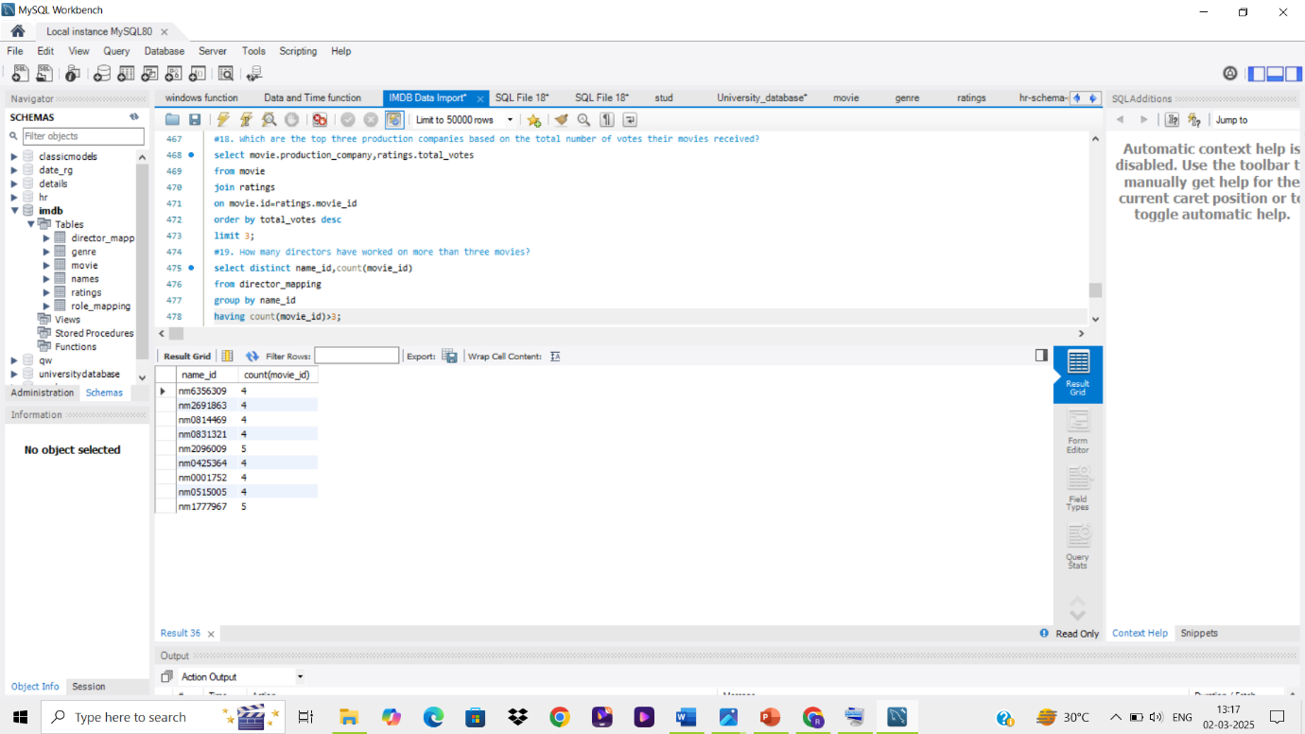

**20. Average Actor and Actress Heights**

**Query:** Calculates the average height of actors and actresses separately.

**Findings:** Provides demographic insights into the industry. 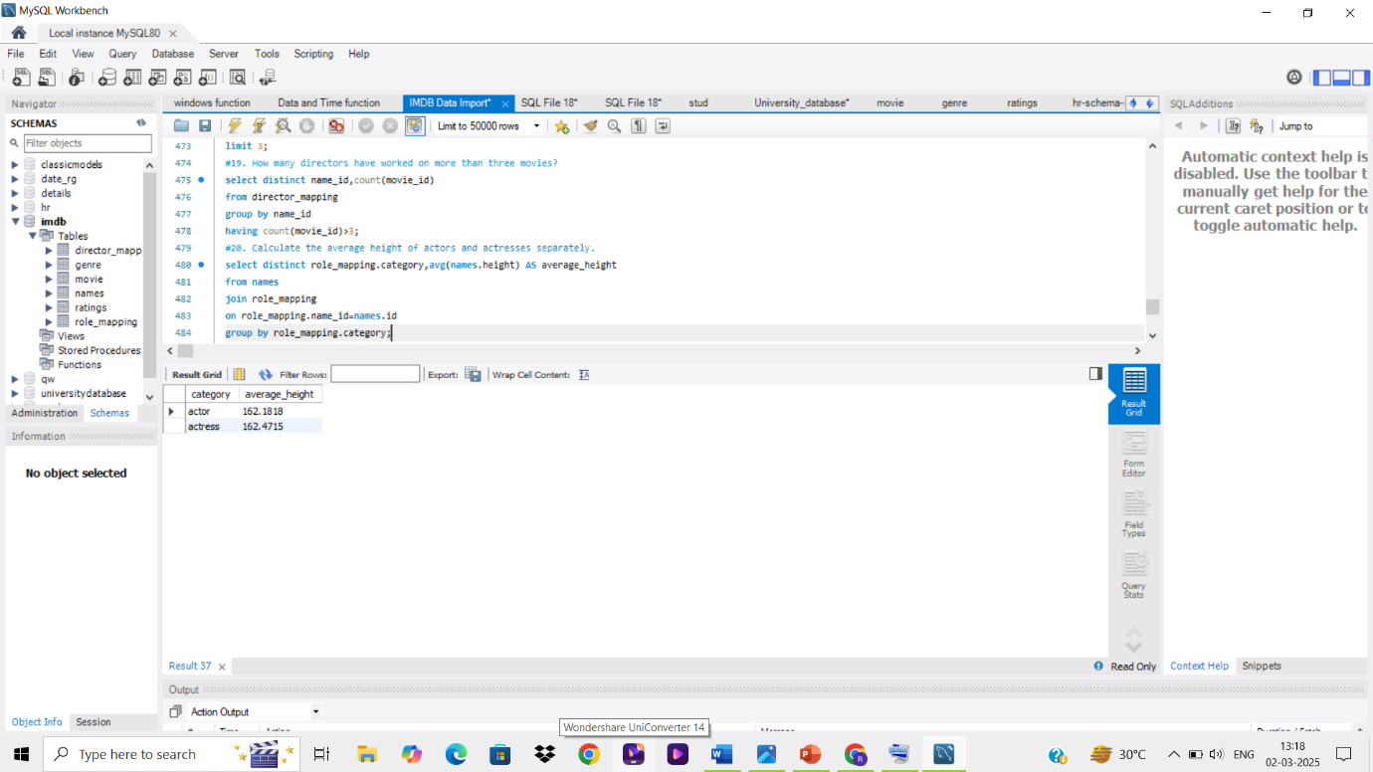

**21.10 Oldest Movies with Director and Country**

**Query:** Lists the 10 oldest movies, including title, country, and director.

**Findings:** Explores early cinema history. 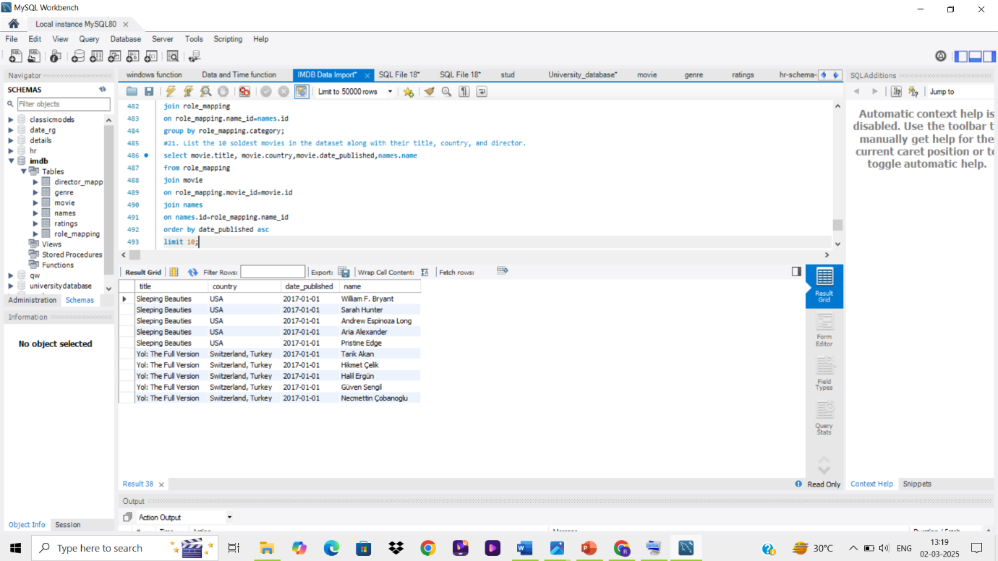

**22 .Top 5 Movies by Total Votes (with Genres)**

**Query:** Identifies the most voted movies along with their genres.

**Findings:** Shows audience preferences in voting trends. 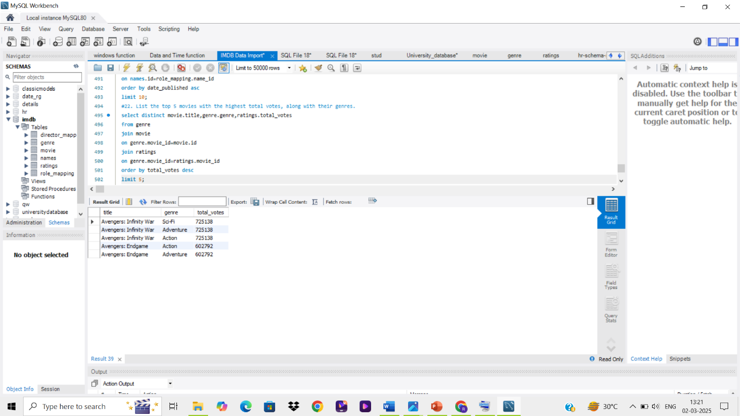

**23.Longest Movie (Genre & Production Company)**

**Query:** Finds the longest-duration movie along with its genre and production company. **Findings:** Highlights notable long-format films. 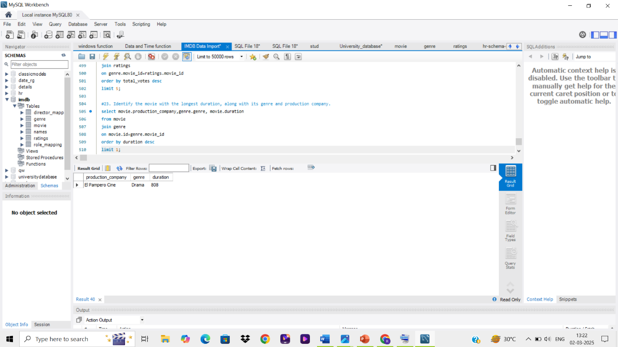

**24. Total Votes for 2018 Movies**

**Query:** Sums up total votes received by movies released in 2018.

**Findings:** Measures engagement levels for that year. 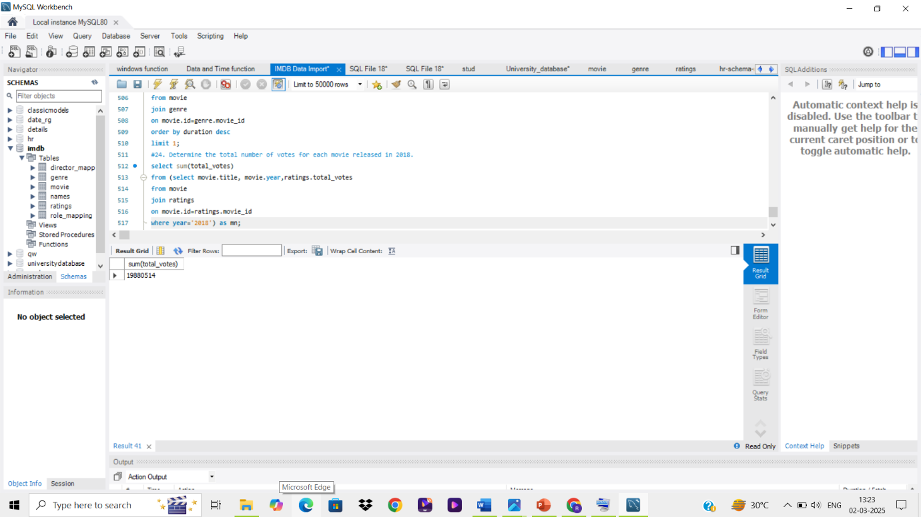

**25. Most Common Movie Language**

**Query:** Determines the most frequently used language in movie production.

**Findings:** Highlights dominant languages in cinema. 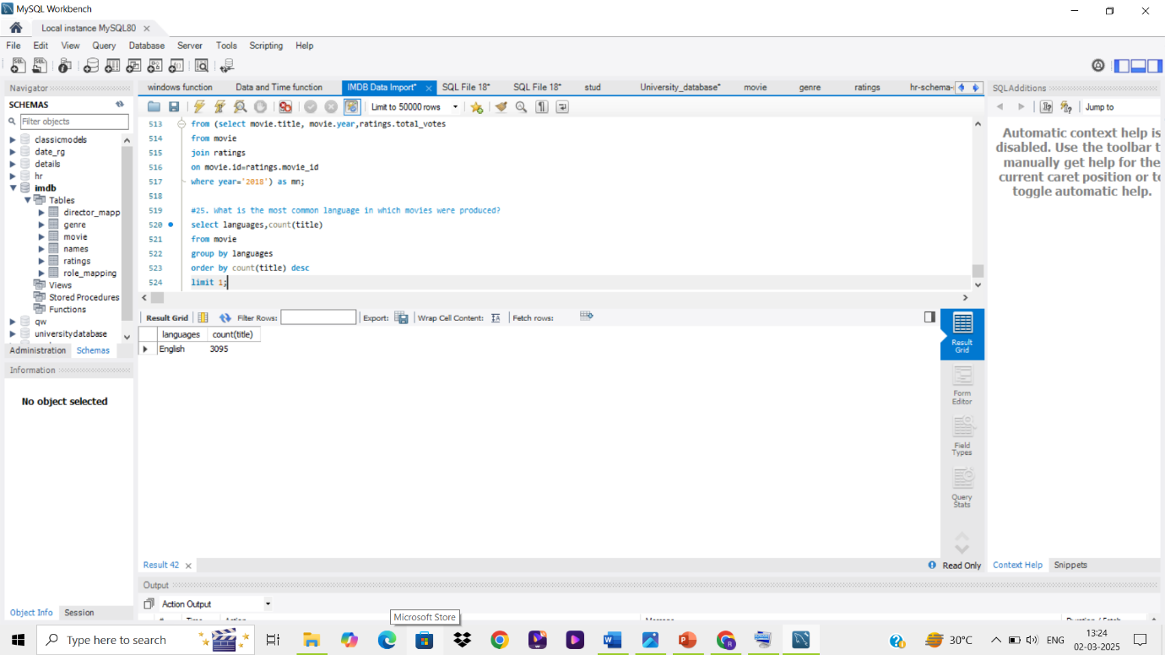

**Conclusion**

This analysis provides valuable insights into movie production trends, audience preferences, and industry patterns. The queries explored various aspects of the dataset, from identifying popular genres to assessing actor performances and rating distributions. The results of this study can be used for further research or decision-making in the film industry.

**Appendix**

Includes SQL code for all queries and screenshots of query outputs.